JMV-130313-4 Spa hotel on the Costa Brava

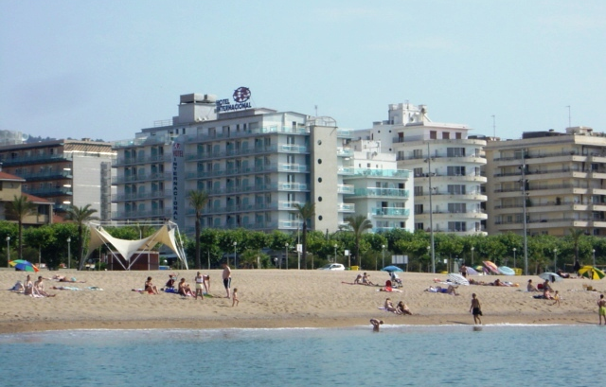
2 * Hotel/旅馆
Country/国家：Spain /西班牙马洛卡
Costa Brava
City/城市： 50 km from Barcelona
Rooms /客房 : 120
Price/ 价格：13,500,000 €
2 * beachfront hotel is located 50 kilometers from Barcelona and Girona.
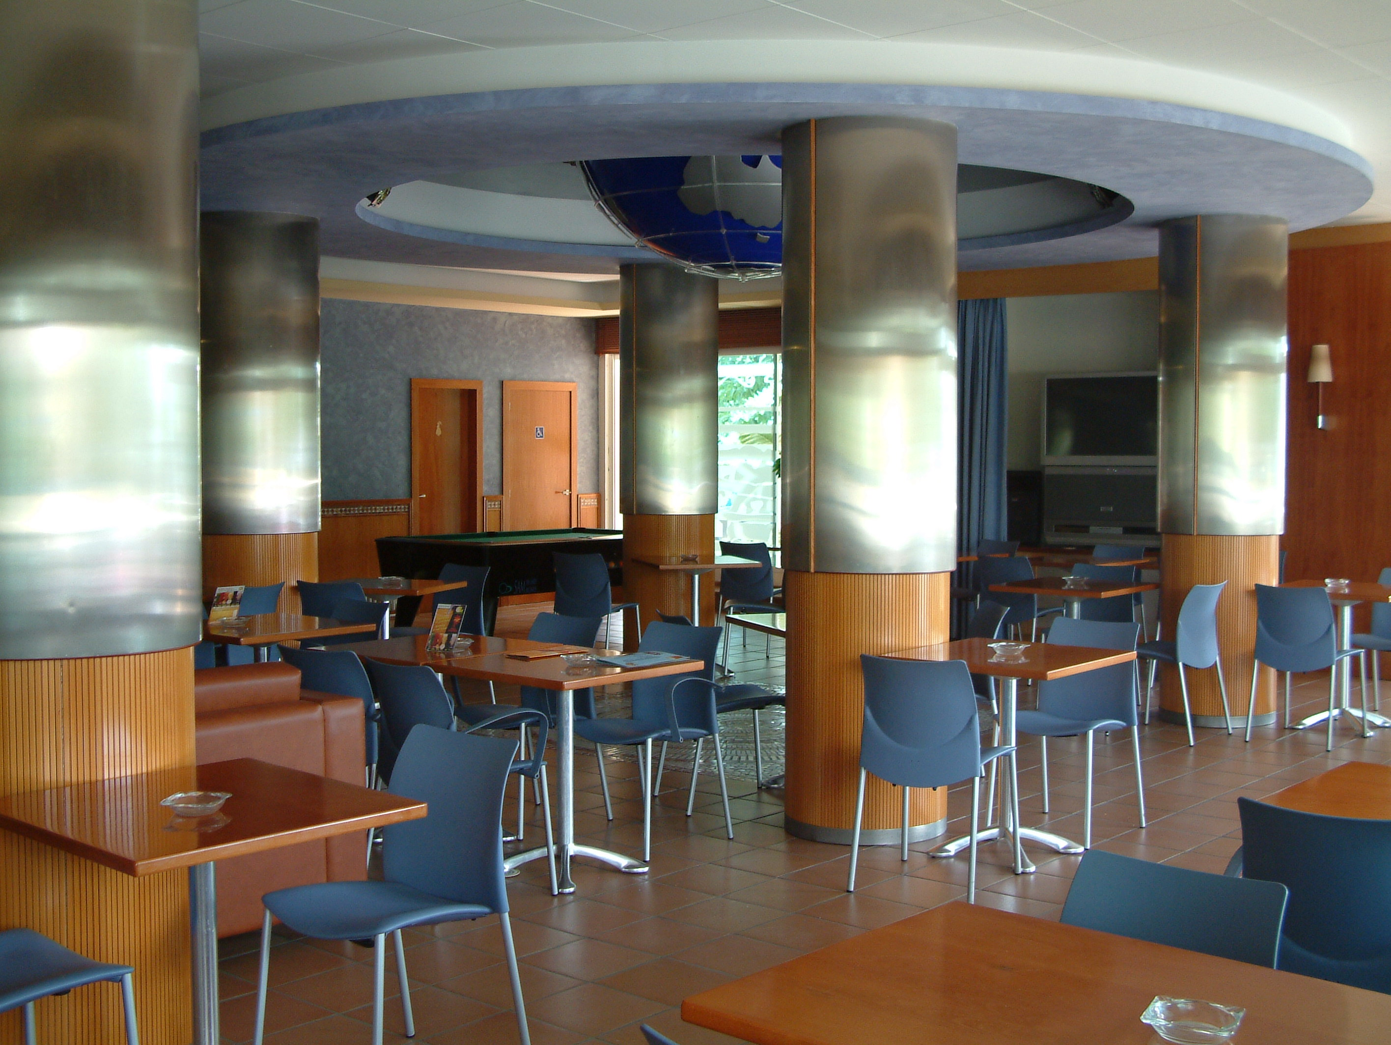
The hotel consists of 9 floors and 120 rooms, most of which have views of the sea.

In the hotel:
• Restaurant for 120 people
• Lobby bar
• Swimming pool for adults and children.
• Laundry
• Parking

If you are interested this property please send request to mail@redfeniksgroup.ru

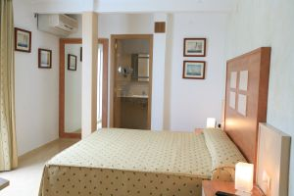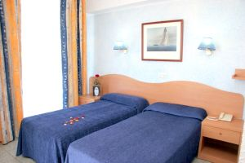
2*海滨酒店，位于50公里从巴塞罗那和赫罗纳。
酒店拥有一共有9层，120间客房，大部分都享有海景。
在酒店：
•120个座位的餐厅
•大堂酒吧
•为成人和儿童游泳池。
•洗衣
•停车场
如果你有兴趣这个属性，请发送请求mail@redfeniksgroup.ru

