ADL-2806-7 A great investment opportunity in the Los Cristianos
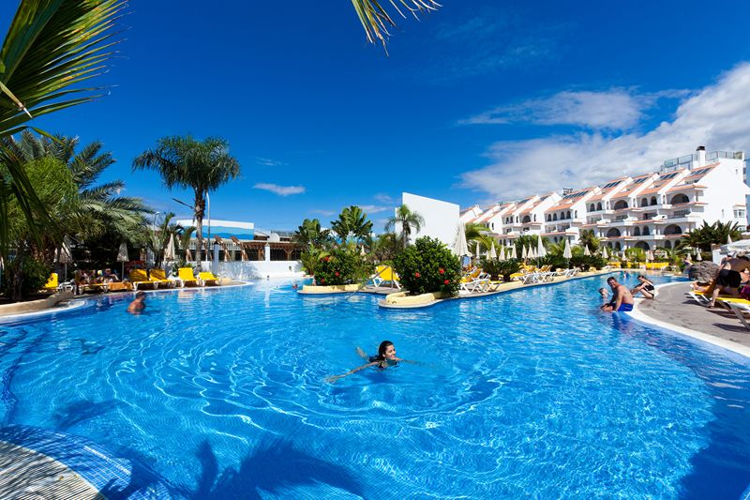

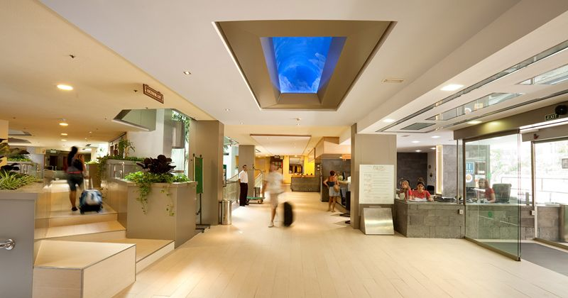
Hotel/旅馆
Country/国家：Spain /西班牙马洛卡
Tenerife, Canary Islands /特内里费岛，加那利群岛
City/城市： Los Cristianos
Price/ 价格：36,000,000 €

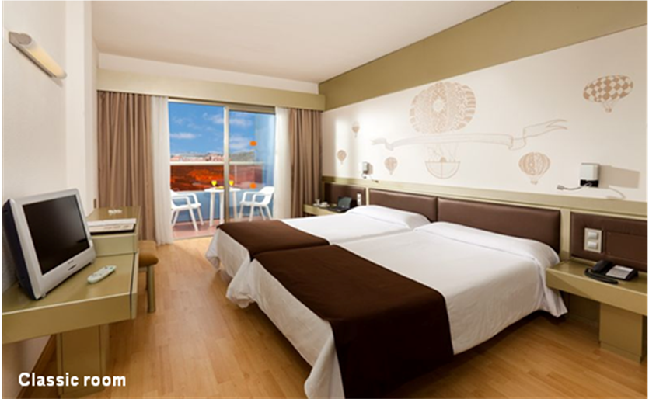
The hotel is located in the upper part of Los Cristianos and includes its own spa center.
At present, the company has 3 credits from the European Central Bank with low interest rates. In the interest of future investor may take these obligations on itself. On January 1, 2013, the total amount of the above loan is 4,270,871 Euro.
Payment Plan could be:
• Down payment: 1,000,000 Euros
• Second installment: 15,729,129 euros
• Sent liabilities 4,270 871.00 euros
Total: 21 000 000,00 EUR
The remaining 15 million euro can be paid during next 5 years.
Hotel has a contract with the largest British tour operator to guarantee purchase of 50% rooms and suites. As a guarantee of maintaining the efficiency of the transit period General Manager and Chief Accountant willing to stay in their posts for a period up to 5 years.
If you are interested this property please send request to mail@redfeniksgroup.ru

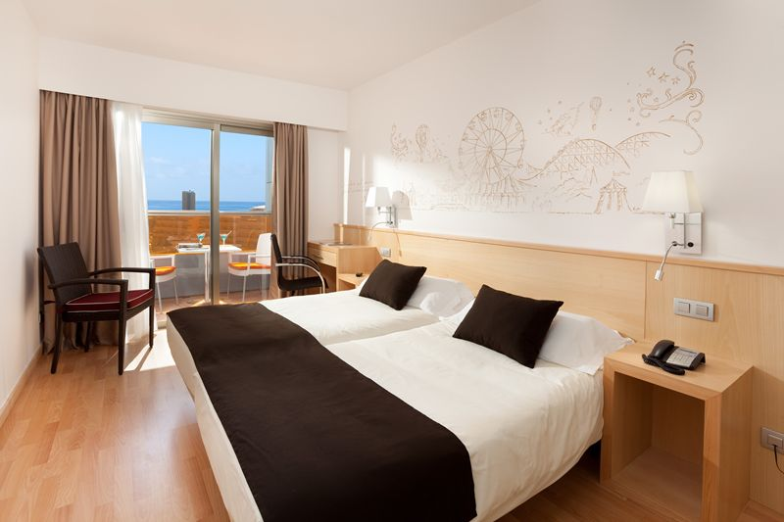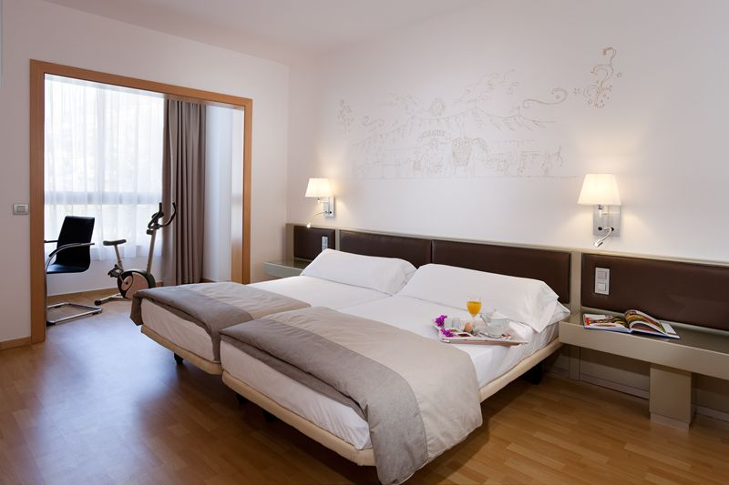

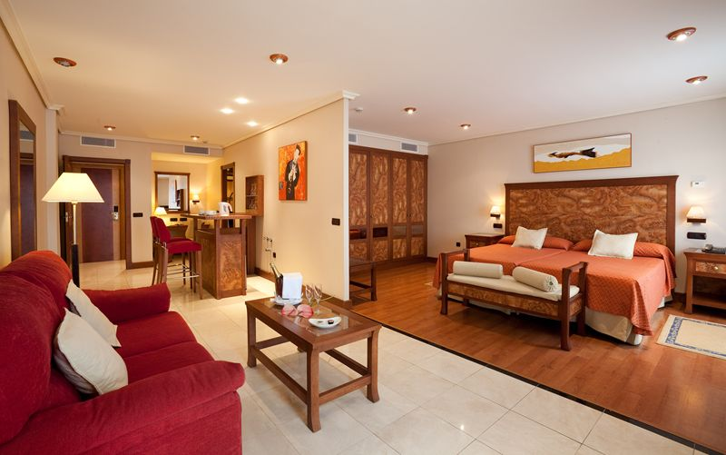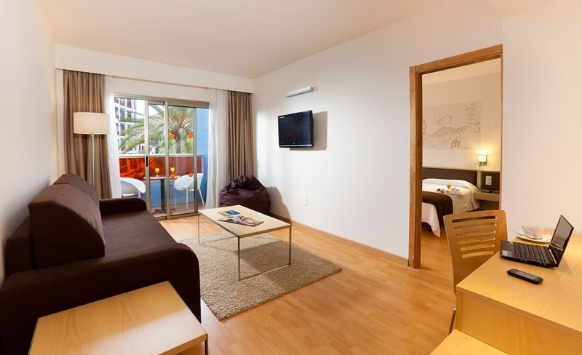

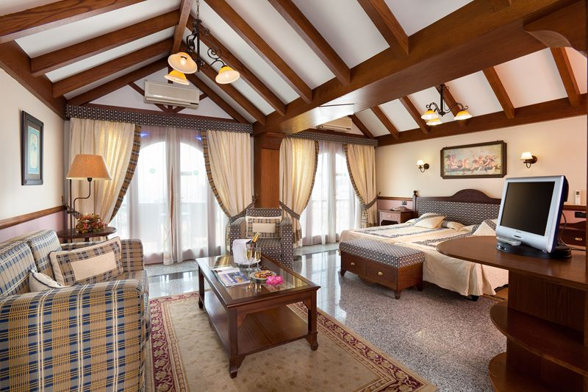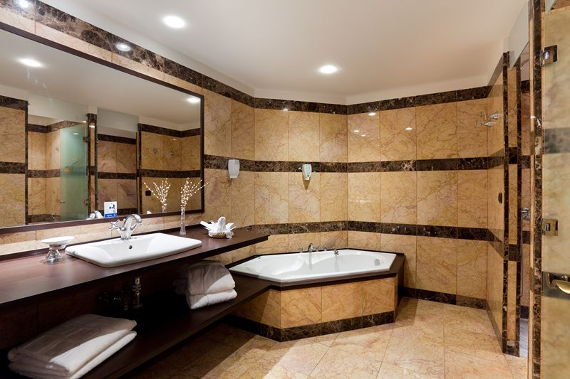

如果你有兴趣这个属性，请发送请求mail@redfeniksgroup.ru

