Building “ELS ESQUIADORS” LLORTS – ANDORRA
建筑出售。
该建筑有16间公寓，在安道尔
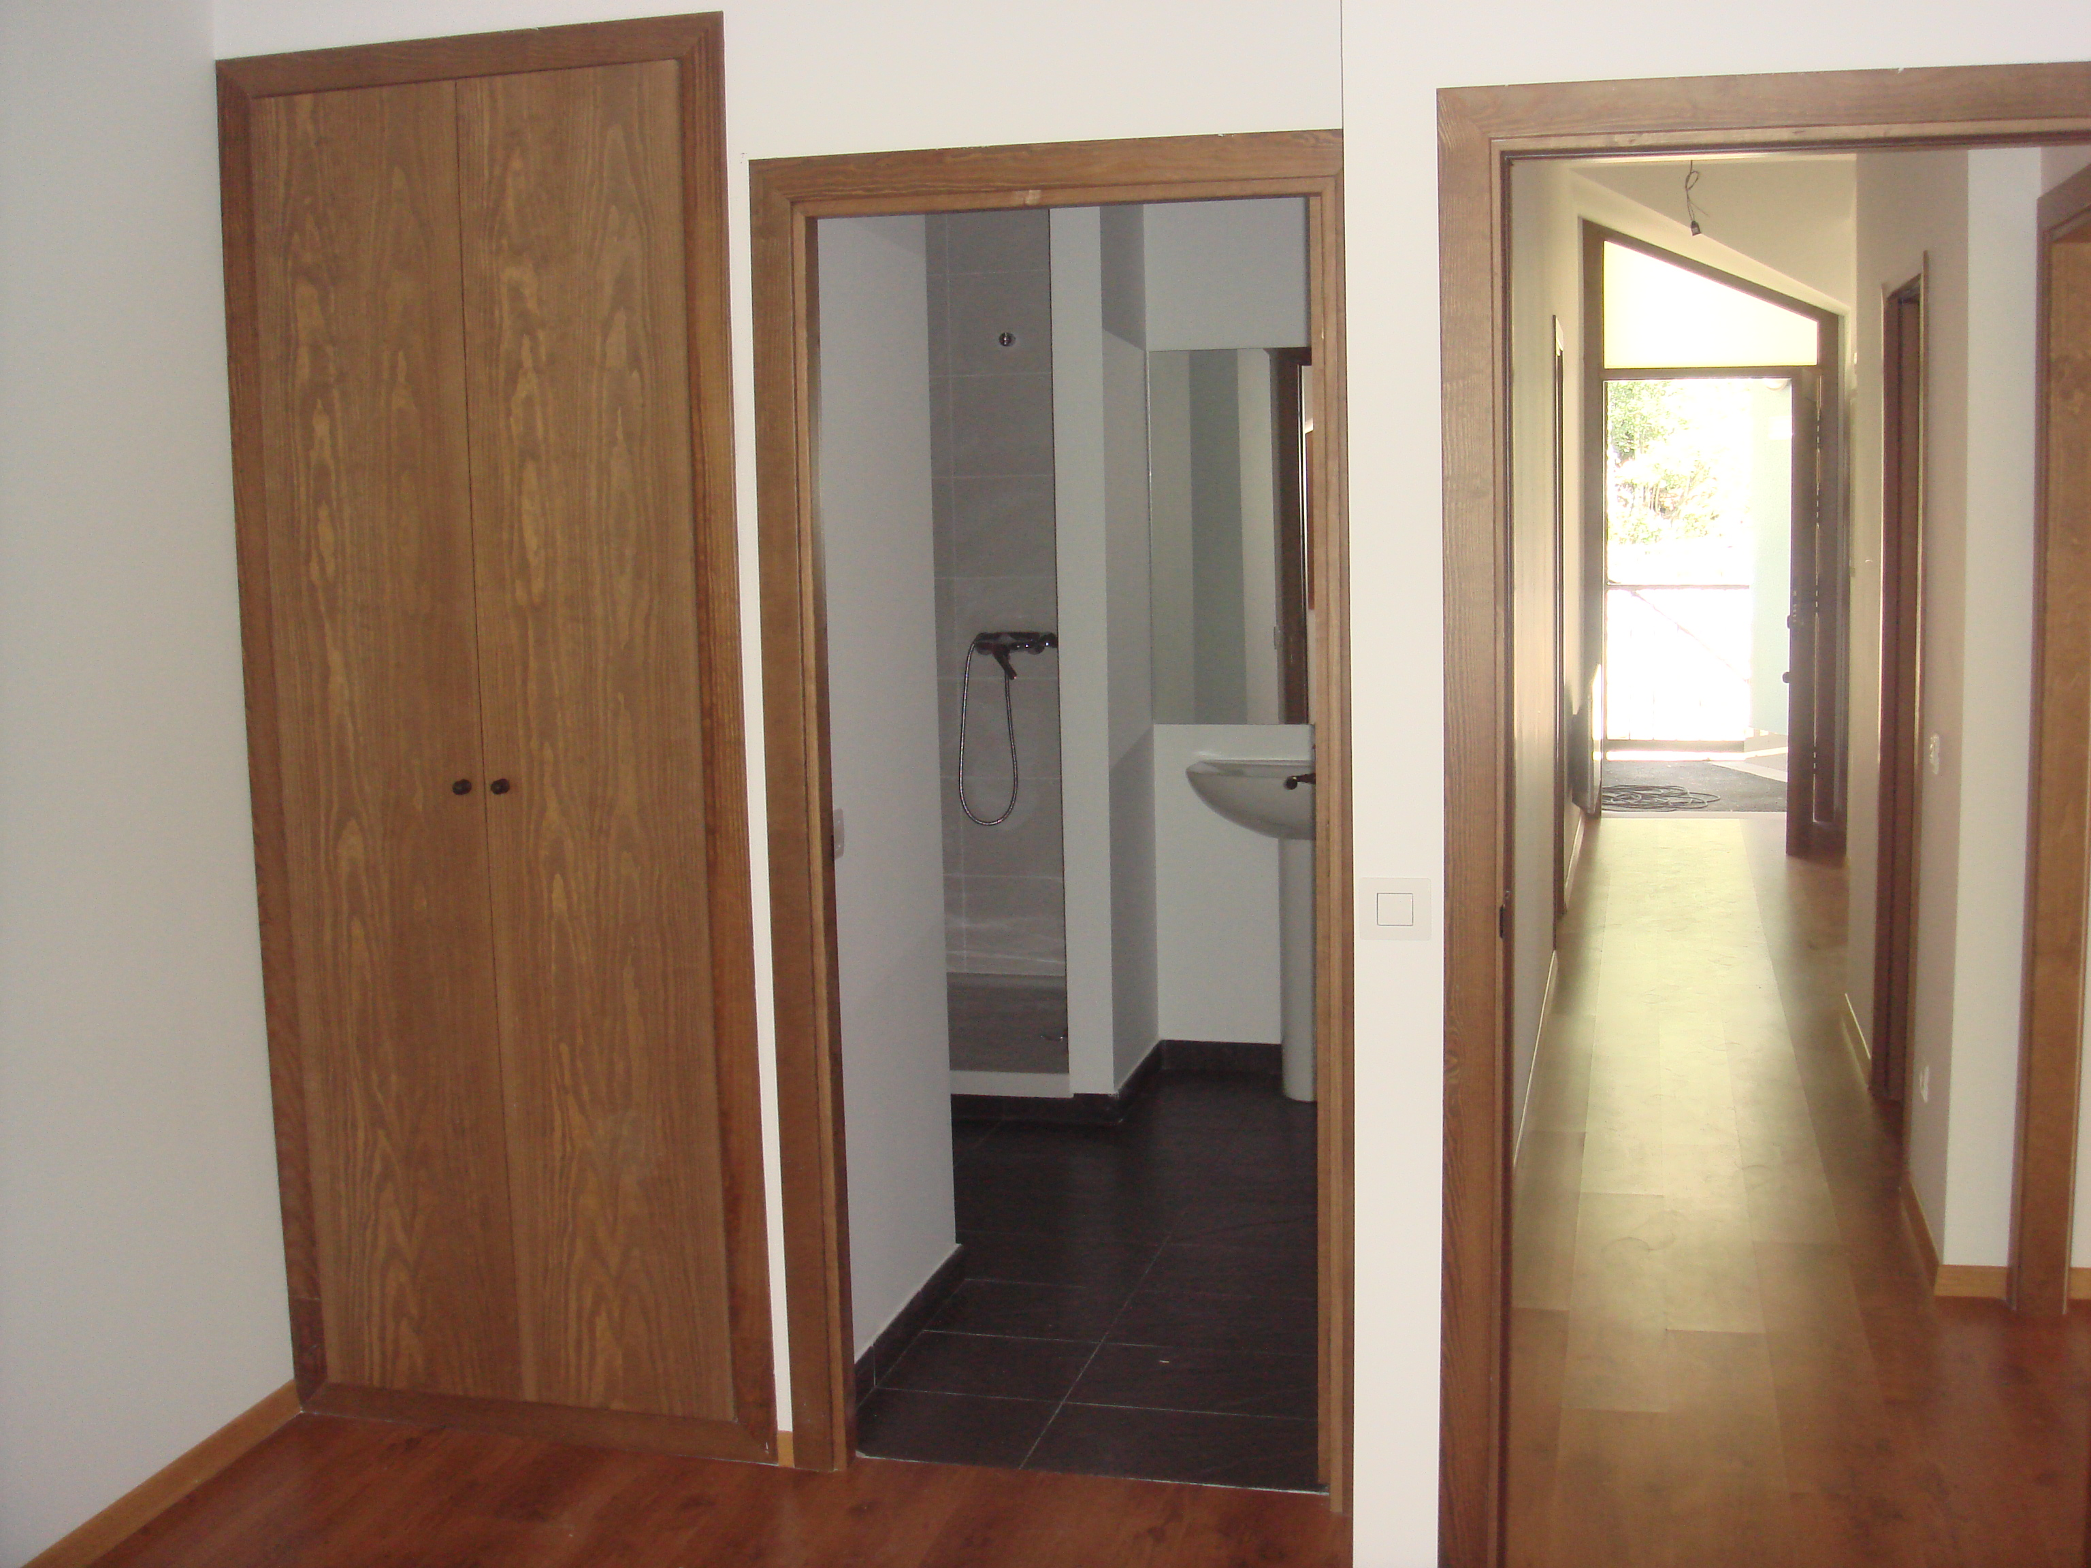
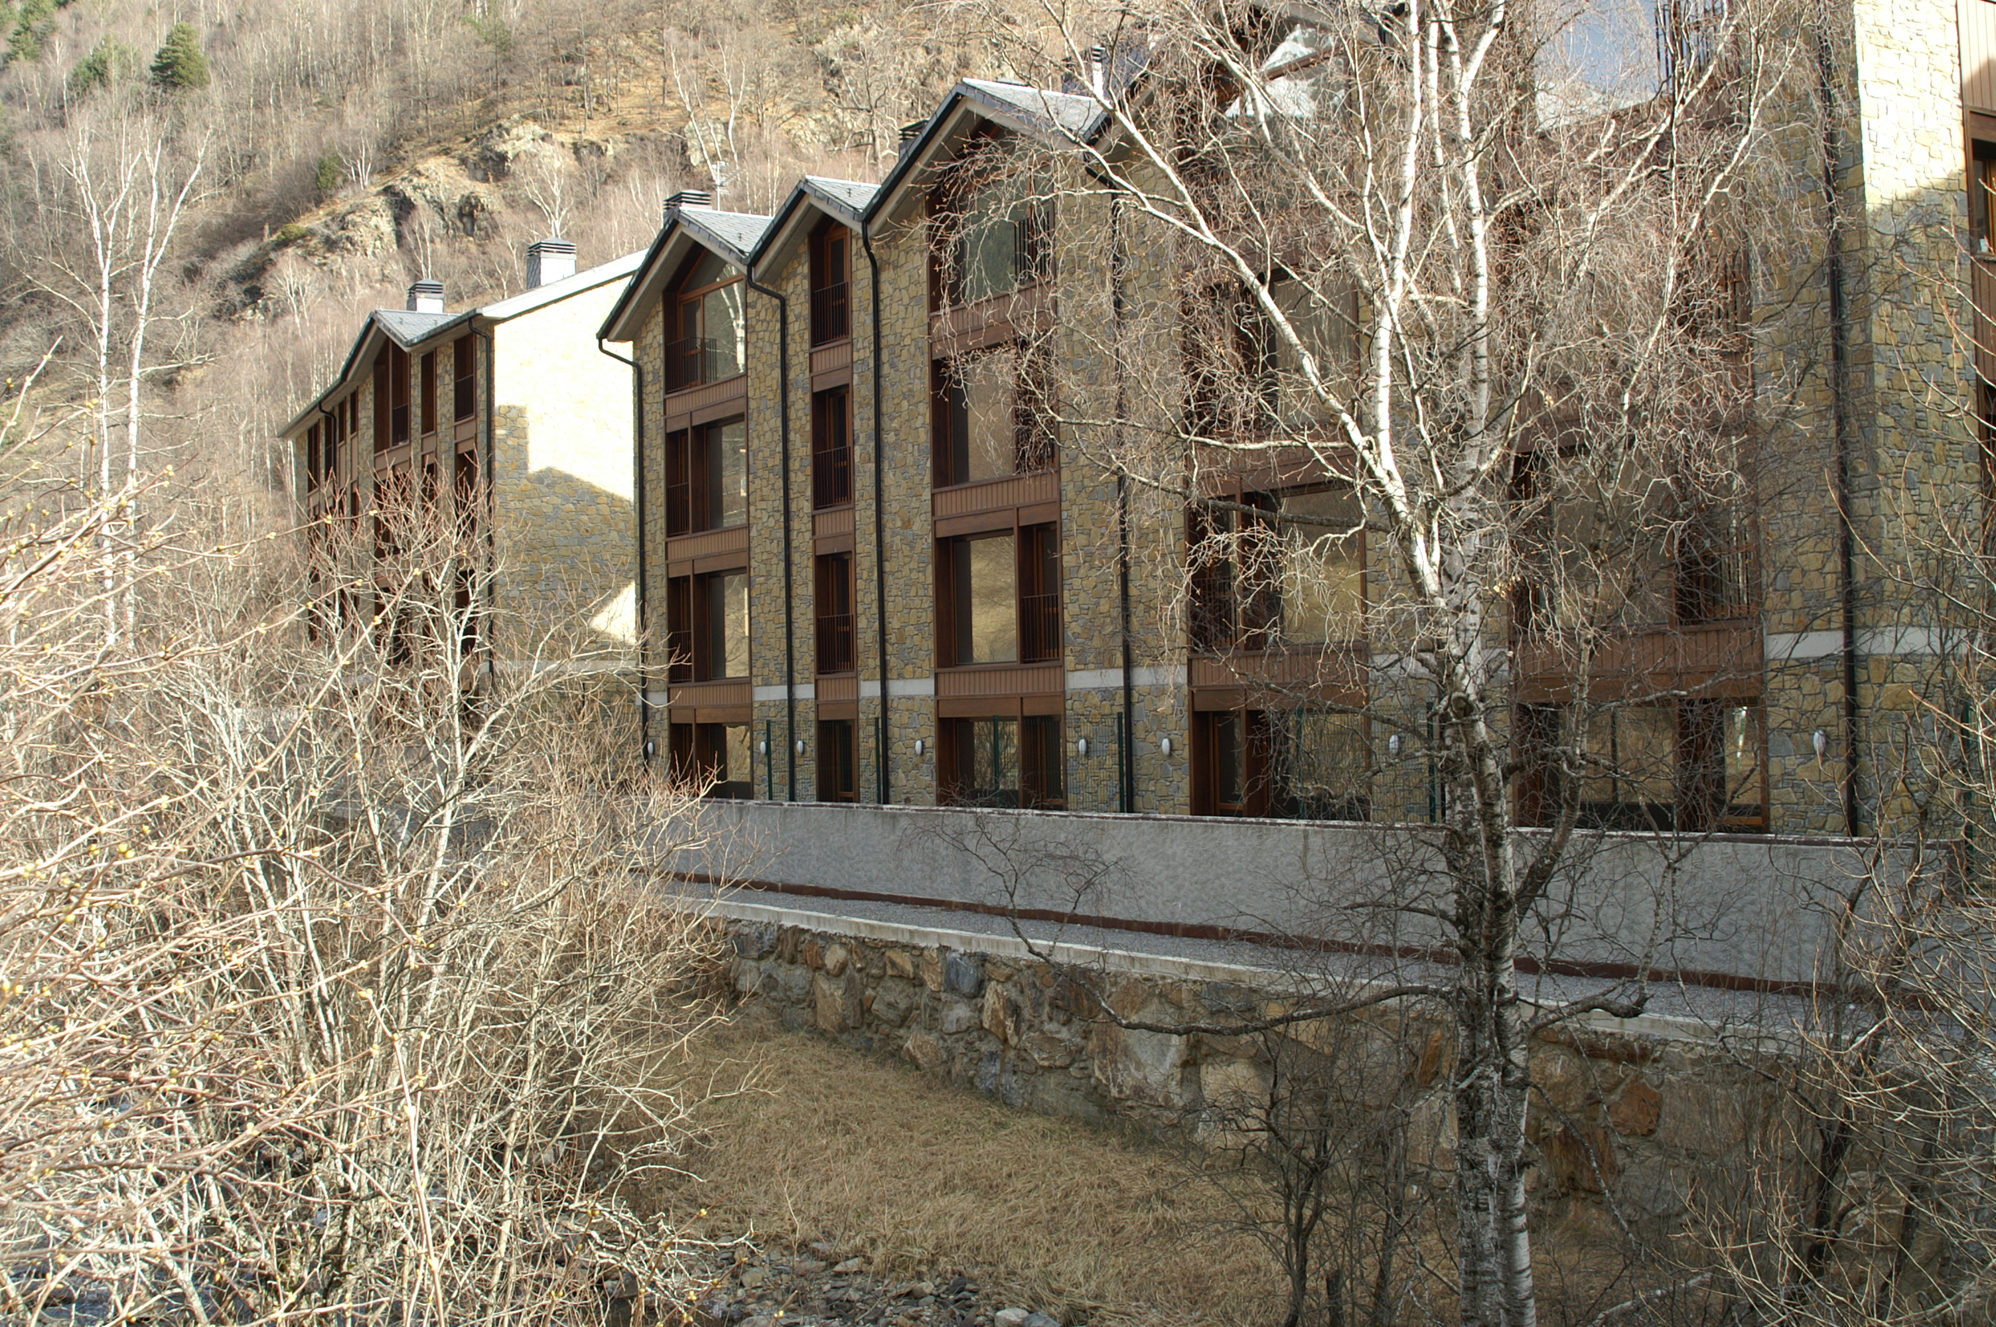
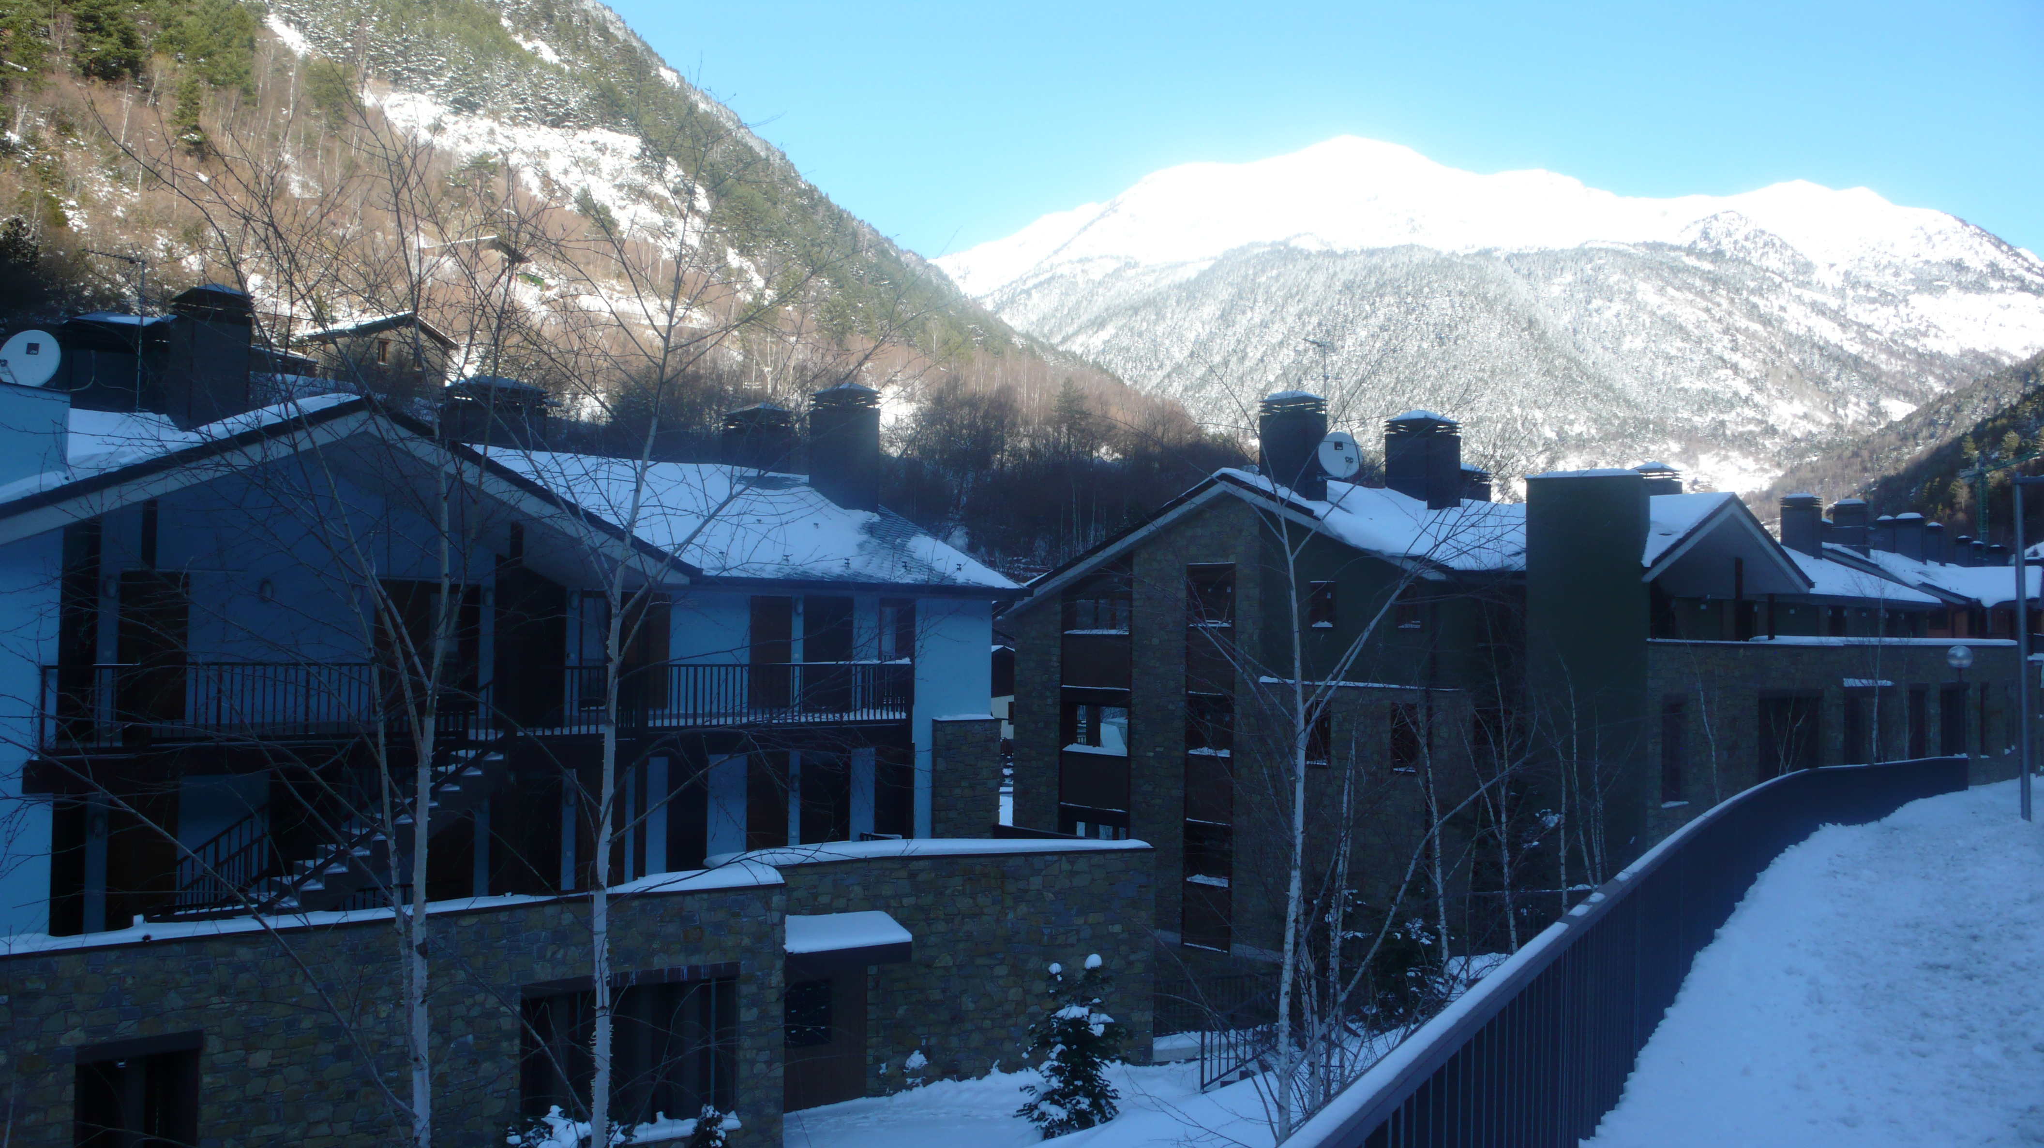
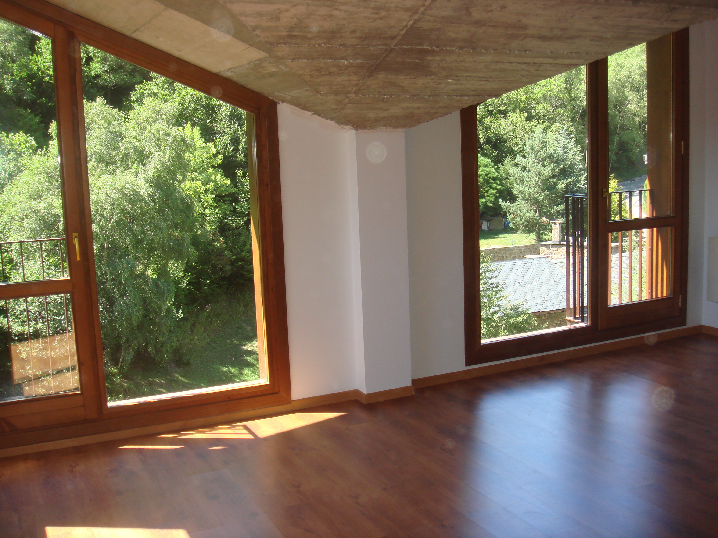
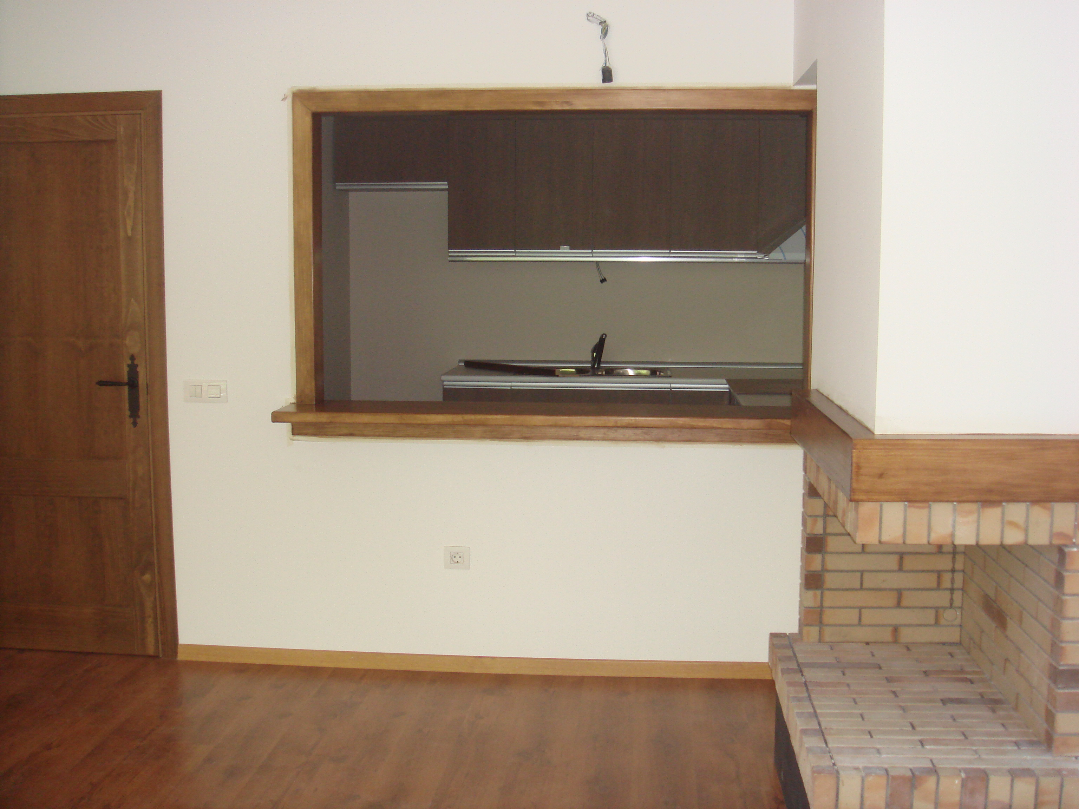
Country/国家：Andorra/安道尔
City/城市： Ordino /奥尔迪诺
Area of each apartment 77 M²
/每间公寓都拥有一个面积77平方米。
Bedrooms/卧室： 2
Bathrooms/浴室：1
Parking space/停车位 : 1
Price for whole building/
整栋楼的价格：2.850.000 €
New building with 16 apartments for sale. The building is situated in LLORTS – ORDINO, 10 minutes from sky station
ORDINO-ARCALIS.
Kitchen is fully equipped with furniture and electric household appliances.
Wooden floores
Fire place is possible.
Electric heating system.
Each level has 4 apartments.
Apartments on the ground level are with a garden.
16 parking spaces. 4 storage rooms.
Common garden and barbeque area.

If you are interested this property please send request
to mail@redfeniksgroup.ru

每个级别都有4套公寓。 16个停车位。 4储藏室。公共花园和烧烤区。设备齐全的厨房家具和家用电器。
木地板。
电加热系统。

如果你有兴趣这个属性，请发送请求 mail@redfeniksgroup.ru

