PRINCIPAT D’ ANDORRA

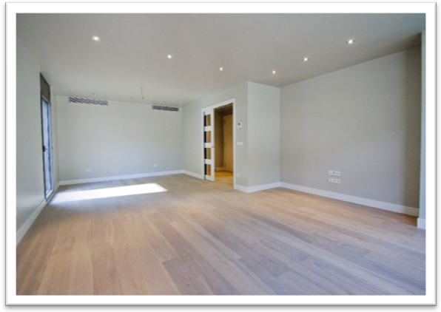
Apartments BRONCE 公寓“青铜”
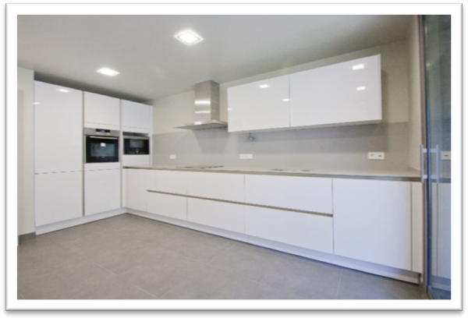
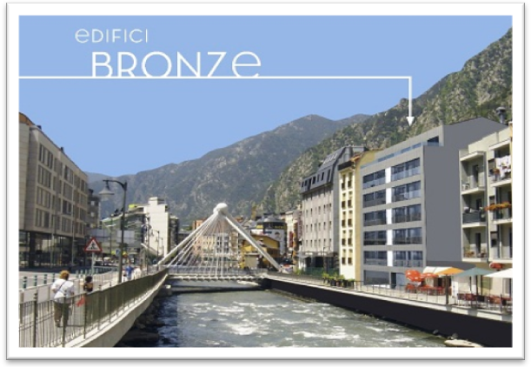
Country/国家： Andorra/安道尔
City/城市：ANDORRA LA VELLA/安道尔城
Bedrooms/卧室： 3
Bathrooms/浴室：2
Area/区域：135 m²/ 135平方米
Parking space/停车位 : 1
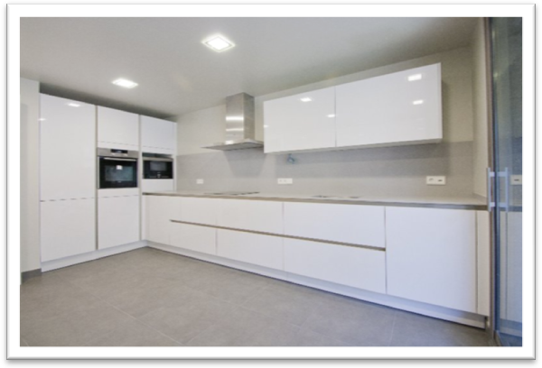
Price from/价格从：1.035.000 €
New apartments Premium Class are situated
in the center of ANDORRA LA VELLA and only 500 m from famouse CENTRO TERMOLÚDICO DE CALDEA.
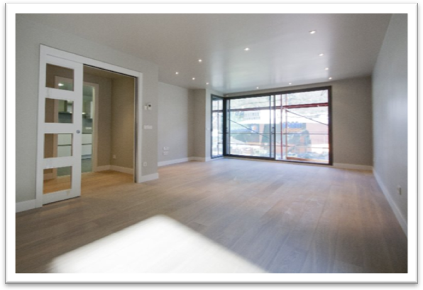
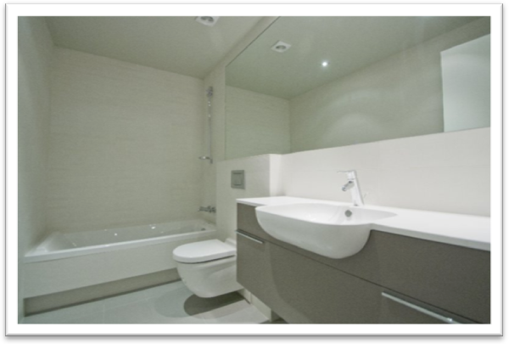
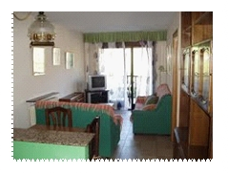
Kitchen is fully equiped , electric houshold appliances are included.
Grand salon with balcony.
Magnificent views from windows.

If you are interested this property please send request to mail@redfeniksgroup.ru

新的划一保费。从安道尔城的中心仅有500米。厨房设备齐全，包括所有电器。
带阳台的大休息室。美丽的景色从窗户和阳台。

如果你有兴趣这个属性，请发送请求 mail@redfeniksgroup.ru

